CHAPTER Three

MEASURES OF LOCATION, SPREAD, AND SKEWNESS

EXERCISES
Exercises 3.1 – 3.7 involve measures of central tendency and require the use of SPSS.

  - For the following variables from the NELS data set, what are the appropriate measures of central tendency (mean, median, mode) and why? Use SPSS to calculate the values of these measures and interpret the results.

- GENDER
- URBAN
- SCHTYP8
- TCHERINT
- NUMINST
- ACHRDG08
- SCHATTRT
- ABSENT12

  - These questions involve the variable LATE12 from the NELS data set.

- How many students in the data set were never late to school?
- How often was the first person in the data set late to school?
- What is a typical number of times students were late to school?

  - For the following variables in the NELS data set, indicate the most appropriate set of summary statistics for summarizing the distribution: (1) frequencies or percentages and mode, (2) median and interquartile range, (3) median, interquartile range, and skewness ratio, (4) mean, standard deviation, and skewness ratio. Your answers should depend upon the level of measurement of the variable as well as the extent to which extreme values are present in the distribution to influence unduly the value of these summary statistics.

- GENDER
- URBAN
- SCHTYP8
- TCHERINT
- NUMINST
- ACHRDG08
- SCHATTRT
- ABSENT12

  - CIGARETT is a dichotomous variable coded 0 for those who have not smoked and 1 for those who have.

- Compute the proportion of those that ever smoked based on the number from the frequency distribution.
- Compute the mean of CIGARETT. Interpret the mean in view of the result of part (a).
- Do a greater proportion of males or females report having ever smoked?

  - In this exercise, we examine measures of central tendency for the variable CIGSPDAY1 in the Framingham data set.

- Create a boxplot showing the distribution of the number of cigarettes smoked per day (CIGPDAY1). Comment upon the presence of outliers in the distribution. Based on the graph, how many cigarettes per day do you think a typical person in the data set smokes?
- Calculate and report the values for the mean and median of CIGPDAY1.
- Which measure of central tendency gives a better description of the number of cigarettes smoked per day by people in the Framingham data set? Why do you suppose that is?

  - In this exercise, we examine the gender difference in the number of cigarettes smoked per day in the Framingham data set, taking into account the presence of one extreme male outlier.

- Create a boxplot showing the distribution of the number of cigarettes smoked per day (CIGPDAY1) by gender (SEX). Comment upon the presence of outliers in the two distributions.
- Are there gender differences in the number of cigarettes smoked per day? Provide statistical support for your answer.

  - It was noted in this chapter that when a unimodal continuous distribution is positively skewed, the mean is generally larger than the median given that extreme values influence the value of the mean more than they do the value of the median. While there are rare exceptions to this rule in the case when a variable is many-valued, in other cases, as exemplified by this exercise, exceptions are more common.

- Create a histogram of the variable TCHERINT from the NELS data set, which contains only four possible values. According to the histogram, what is the shape of the distribution?
- Which is larger, the mean of TCHERINT, or the median?

Exercise 3.8 involves measures of dispersion and the NELS data set.

  - Which measure(s) of dispersion or variability (range, Interquartile range, standard deviation, or variance), if any, may be used appropriately to measure the spread of the following variables from the NELS data set? Report these values. In stating your answer, take into account both the level of measurement of the variable and whether there are extreme values in its distribution that could unduly influence the value of certain dispersion statistics, making them less representative of the distribution as a whole.

- GENDER
- URBAN
- NUMINST
- ACHRDG08
- SCHATTRT
- ABSENT12

Exercises 3.9 – 3.14 involve selecting a relevant SPSS procedure and calculating and interpreting a variety of appropriate summary statistics using variables from the NELS data set.

  - Use SPSS to find the following summary descriptive statistics for a student’s self-concept in eighth grade (SLFCNC08).

- Minimum
- Maximum
- 40th percentile
- 25th percentile
- Mean
- Median
- Mode
- Range
- Interquartile range
- Variance
- Standard deviation
- Skewness
- Standard error of the skewness

  - The following questions investigate how, among the students in the NELS data set, tenth grade math achievement (ACHMAT10) is related to whether or not the student’s family owned a computer when he or she was in eighth grade (COMPUTER). Use the SPSS Explore procedure to generate the values of appropriate statistics to answer the related questions.

- Compare the shape of the distributions of ACHMAT10 for those who did and those who did not own a computer in eighth grade. Begin by constructing boxplots of ACHMAT10, one for each value of COMPUTER and follow up by calculating skewness ratios.
- Is tenth grade math achievement typically higher or lower for students whose families owned a computer when they were in eighth grade than students whose families did not own a computer when they were in eighth grade? Explain and support your answer with the value of at least one appropriate descriptive statistic, indicating if any other statistics contradict your conclusion.
- Among students in the NELS data set, is tenth grade math achievement more or less variable for students whose families owned a computer when they were in eighth grade? Explain and support your answer with the value of at least one appropriate descriptive statistic, indicating if any other statistics contradict your conclusion.

  - This exercise addresses differences in socio-economic status (SES) by urbanicity (URBAN) for students in the NELS data set. Use the Explore procedure to generate the descriptive statistics that will be used for answering the following questions.

- Describe the shape of SES for each of the three levels of URBAN.
- What type of student has the highest typical socio-economic status, those from urban, suburban, or rural settings? Support your answer with appropriate descriptive statistics, indicating whether all such statistics support your conclusion.
- For what type of setting is the socio-economic status of the students most dispersed, those from urban, suburban, or rural settings? Support your answer with appropriate descriptive statistics, indicating whether all such statistics support your conclusion.
- In what type of setting does the person with the highest socio-economic status live, urban, suburban, or rural?

  - Answer the following questions to compare eighth grade self-concept (SLFCNC08) to twelfth grade self-concept (SLFCNC12) for students in the NELS data set.
    - Is the distribution of self concept scores in the NELS data set severely skewed in either eighth or twelfth grade? If the distribution is severely skewed, indicate the direction of the skew. If the distributions are severely skewed, indicate which is more skewed. Explain and support your answer using the value(s) of at least one appropriate statistic.
    - Do students in the NELS data set typically have higher self-concept scores in eighth or twelfth grade? Explain and support your answer with the value(s) of at least one appropriate statistic.
    - Are the self-concept scores of students in the NELS data set more heterogeneous in eighth or twelfth grade? Explain and support your answer with the value(s) of at least one appropriate statistic.

  - In this exercise, we explore differences between males and females on three variables in the NELS data set, one affective, another cognitive, and the third, behavioral.

- Are males and females similar in terms of the extent to which they believe teachers show an interest in them (TCHERINT)? Begin by considering similarities in their distributions by constructing a population pyramid, using the following instructions. Follow up by using the Explore procedure to obtain a comparison of measures of central tendency for these interest scores across gender.

To obtain the population pyramid, click on Graphs, Legacy Dialogs, Population Pyramid. Put TCHERINT in the Show Distribution Over box and GENDER in the Split By box. Click OK.

- Do males and females display similar patterns of change in achievement in reading across eighth (ACHRDG08), tenth (ACHRDG10), and twelfth grades (ACHRDG12)? Begin with boxplots, and, then use the Explore procedure to obtain a comparison of measures of central tendency for these achievement scores across grades.

- Do males and females have similar patterns of school attendance in grade 12 as measured by ABSENT12, CUTS12, and LATE12? Does one gender report greater incidents of absenteeism than the other? Begin by constructing boxplots. Given the ordinal nature of these three variables, follow-up with EXPLORE to calculate medians, IQR’s, and skewness for all three variables by gender.

  - Taking advanced math in eighth grade is often thought to be a proxy for being a more serious student, who is on a college bound track. In this exercise we explore differences on a number of academic and non-academic variables between those who did and did not take advanced math in eighth grade (ADVMATH8).

- Do those who took advanced math in eighth grade report having spent more time per week on homework outside of school in twelfth grade (HWKOUT12) than those who did not take advanced math in eighth grade? Construct a boxplot for each group and follow-up with appropriate descriptive statistics for this ordinal variable.
- Do those who took advanced math in eighth grade report typically fewer incidents of absenteeism in twelfth grade (ABSENT12) than those who did not take math in eighth grade? Construct a boxplot for each group and follow-up with appropriate descriptive statistics for this ordinal variable.
- Is there a difference between those who took advanced math in eighth grade and those who did not in terms of the number of post-secondary institutions they attended (NUMINST). Recall the NUMINST is a ratio-leveled variable. Begin by constructing a population pyramid as described in Exercise 3.13a) and then follow-up with descriptive statistics using Explore.

Exercises 3.15 – 3.16 are based on data sets other than the NELS and relate to a variety of summary statistics.

  - Create a stem-and-leaf plot of the variable READCOMP from the Learndis data set. Use it to answer the following questions.

- What term best describes the shape of this distribution: positively skewed, negatively skewed, or symmetric?
- What is the mode reading comprehension score for these students? If there is more than one mode, report them all.
- What is the maximum reading comprehension score for these students?
- Without calculating, which is probably larger for these students, the mean reading comprehension score or the median comprehension score? Explain.
- Without calculating it, which statistic would probably be best to summarize the spread of this distribution? Explain.
- Which boxplot below (A, B, or C) best describes the data in the stem-and-leaf plot?

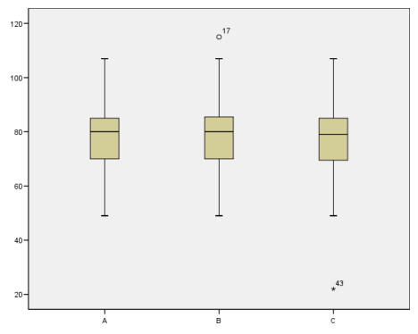

  - This question explores variables from the Framingham data set. Provide a demographic assessment by sex of this sample of individuals at baseline with respect to the following variables.

  - Age (AGE1)
  - Total Serum Cholesterol (TOTCHOL1)
  - Blood Pressure (Systolic and Diastolic) (SYSBP1 and DIASBP1)
  - BMI (BMI1)
  - Current Cigarette Smoker (CURSMOKE1)
  - Number of Cigarettes Smoked Per Day (CIGPDAY1)

Exercises 3.17 – 3.19 require some computation by hand to reinforce your understanding of how the values provided by SPSS are derived. In so doing, we believe that your conceptual understanding of these descriptive statistics will be enhanced.

  - Use the Statisticians data set in this exercise.

- Calculate the mean, median, mode, range, interquartile range, variance, and standard deviation of the variable AMSTAT by hand.
- Use SPSS to check your answers to part a).
- Demonstrate that the sum of the deviations about the mean equals 0.

  - The following distribution of initial blood pressure values comes from the Blood data set.

107 110 123 129 112 111 107 112 135 102 123
109 112 102 98 114 119 112 110 117 130

- Calculate the mean, median, mode, range, interquartile range, variance, and standard deviation of the distribution by hand.
- Calculate the mean, median, mode, range, interquartile range, variance, and standard deviation of the distribution using SPSS.

  - Create a frequency distribution table of the variable IQ from the Learndis data set. Use it to answer the following questions.

- Estimate Q₁, Q₂, and Q₃ for this distribution based on the frequency distribution table.
- Estimate the interquartile range for this distribution.
- Suppose an error were found in the data, and two of the cases classified as 6 years old were really 5 years old. After the data is corrected, which of the mode, median, and mean will have changed, and in which direction?

Exercises 3.20 – 3.38 test your conceptual understanding and do not require the use of SPSS.

  - For a sample of size 12, the mean is 4, the median is 5, and the mode is 6. Is it true that the sum of the raw scores is 36?

3.20. For each of parts (a)–(g), create a (possibly different) data set with five numbers from -5 to 5 (with repeats allowed) for which

- The mean, median, and mode are all equal.
- The mean is greater than the median.
- The mode is higher than the median or mean.
- The mean is 0.
- The standard deviation is as small as possible.
- The distribution is negatively skewed.

3.21. Three different people correctly report the typical wage of a group of five wage earners to be $5,000, $7,000, and $10,000. Explain how this is possible. Find a set of five wages that can correctly be said to have these three measures of location.

3.22. Show that a distribution with a higher mean does not necessarily have a higher standard deviation. Construct two distributions, X and Y, with two scores each, so that X has the larger mean and Y has the larger standard deviation.

3.23. Show that a distribution with a higher mean does not necessarily have a higher median. Construct two distributions, X and Y, so that X has the larger mean and Y has the larger median.

3.24. Show that a distribution with more values does not necessarily have a higher standard deviation. Construct two distributions, X and Y, so that X has more values in its distribution, but Y has the larger standard deviation.

3.25. Construct a distribution X for which the mode is not the majority response.

3.26. Is it possible for the standard deviation of a distribution to be more than half the range? Explain.

3.27. Show that a symmetric distribution exists for which the mean does not equal the mode, by sketching the graph of such a distribution.

3.28. Show that a distribution can have outliers and still be symmetric, by sketching the graph of such a distribution.

3.29. Show that a distribution with a higher maximum does not necessarily have a higher mean. Construct two distributions, X and Y, so that X has a higher maximum value, but Y has a higher mean.

3.30. Show that a skewed distribution can be consistent. Construct two distributions, X and Y, so that X is less skewed, but Y is more consistent.

3.31. Show that a skewed distribution can contain low typical scores. Construct two distributions, X and Y, so that X is more skewed, but Y has a larger mean.

3.32. Answer the following questions about statistics reported in the March 2013 article, “TheKnot.com and WeddingChannel.com Reveal Results of Largest Wedding Study of its Kind, Surveying more than 17,500 Brides.” The relevant information is contained in the questions themselves, but the interested reader may look up the article at http://www.prnewswire.com/news-releases/theknotcom-and-weddingchannelcom-reveal-results-of-largest-wedding-study-of-its-kind-surveying-more-than-17500-brides-195856281.html.

  - According to the survey, the average wedding budget in 2012 was $28,427, excluding honeymoon. If someone wanted to encourage you to spend as much as possible on your wedding, which would be better to report, the mean or the median? Explain.
  - The average marrying age for brides in the US is 29. Do you think that the standard deviation is closer to 3 days, 3 months, or 3 years? Explain.

3.33. Consider the distribution, for all children in the United States, of the ages at which they enter kindergarten. Do you think that the standard deviation of this distribution is closer to 5 years or 5 months? Explain.

3.34. Assume that on a final exam, the raw scores for student performance were severely negatively skewed.

- What is probably true about the performances of the students in the class on the exam?
- If the exam were to be curved, which is preferable from a student perspective, that the median be set to a B- or that the mean be set to a B-?

3.35. Match each set of summary statistics (A, B, C, D, E) with the corresponding histogram (X1, X2, X3, X4, X5) below. Computations are not necessary to complete this exercise.

 | A | B | C | D | E
Mean | 4.5 | 5 | 5 | 5.5 | 6
Standard Deviation | 1.96 | 1.23 | .82 | 1.96 | 1.23

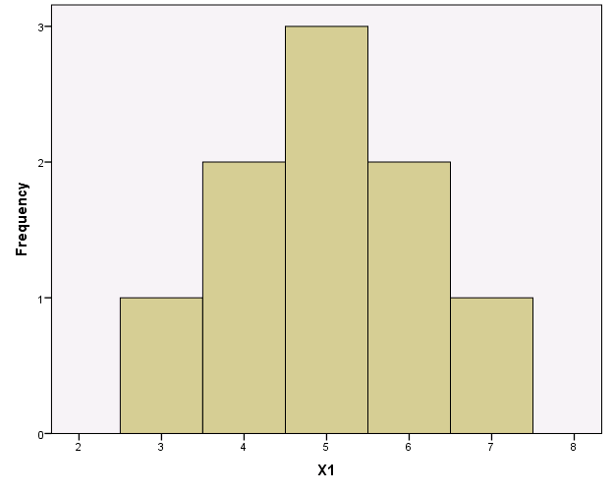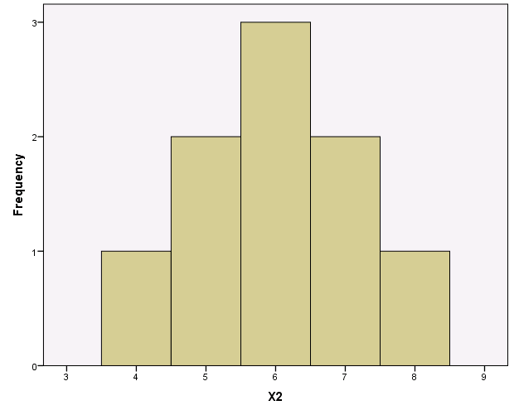

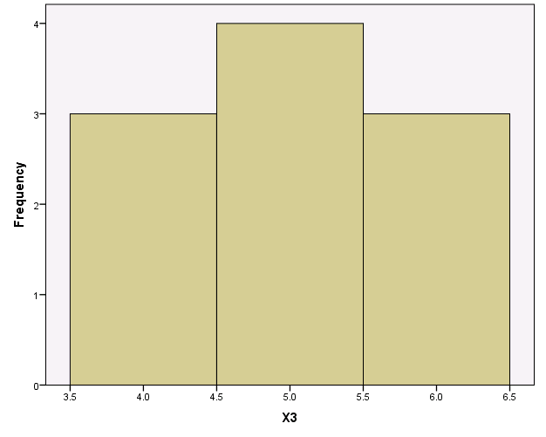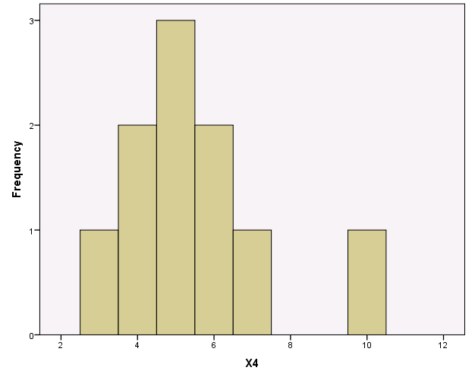

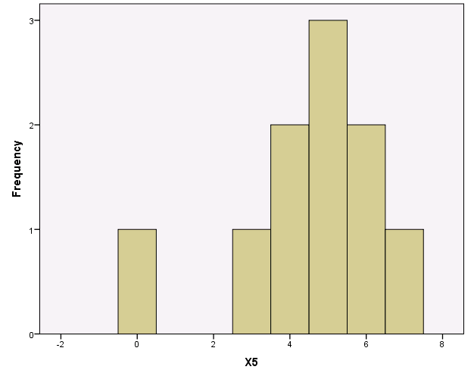

3.36. The following excerpt was taken from an editorial by Paul Krugman in the New York Times on January 21, 2003 (p. 23):

“On Saturday, in his weekly radio address, George W. Bush declared that ‘the tax relief I propose will give 23 million small-business owners an average tax cut of $2,042 this year.’ That remark is intended to give the impression that the typical small-business owner will get $2,000. But as the Center on Budget and Policy Priorities points out, most small businesses will get a tax break of less than $500; about 5 million of those 23 million small businesses will get no break at all. The average is more than $2,000 only because a small number of very wealthy businessmen will get huge tax cuts.”

- What is the shape of the distribution of tax cuts for small business owners?
- What would you guess is the value of the median of the distribution of tax cuts for small business owners?
- Would you suppose that the standard deviation is smaller or larger than $500? Explain.

3.37. Among women in the U.S. aged 40-49, would you expect the mean number of living children per woman to be less then, greater than, or about the same as the median number of living children per woman? Explain your answer.

3.38. Assume your course average is based on a midterm exam worth 100 points and a final exam that also is worth 100 points. Assume also that the midterm exam counts 40% of your course average and the final exam counts 60% of your course average. If you scored 80 on the midterm exam and 85 on the final exam, what is your average grade for the course?

